Active PoE Switch

⚙️ What is an Active PoE Switch?
# Source: Chatgpt (GPT‑5 Mini) at [12/18/2025]
An Active PoE Switch is a network switch that provides Power over Ethernet (PoE) using IEEE standard protocols like 802.3af, 802.3at (PoE+), or 802.3bt (PoE++). It is designed to automatically detect and safely power compatible devices (like IP cameras, VoIP phones, or wireless access points) over the same Ethernet cable used for data.

🔌 How Active PoE Works
# Source: Chatgpt (GPT‑5 Mini) at [12/18/2025]
- The switch checks whether a connected device supports PoE.
- If it does, the switch delivers regulated power based on the device’s needs.
- If not, it sends only data — no risk of damage to the device.
✅ This intelligent detection is what makes it "active".

🔧 Key Features of an Active PoE Switch
# Source: Chatgpt (GPT‑5 Mini) at [12/18/2025]
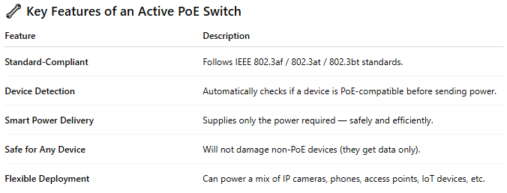

Feature | Description
Standard-Compliant | Follows IEEE 802.3af / 802.3at / 802.3bt standards.
Device Detection | Automatically checks if a device is PoE-compatible before sending power.
Smart Power Delivery | Supplies only the power required — safely and efficiently.
Safe for Any Device | Will not damage non-PoE devices (they get data only).
Flexible Deployment | Can power a mix of IP cameras, phones, access points, IoT devices, etc.

🧪 PoE Standards
# Source: Chatgpt (GPT‑5 Mini) at [12/18/2025]
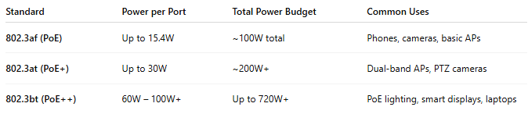

Standard | Power per Port | Total Power Budget | Common Uses
802.3af (PoE) | Up to 15.4W | ~100W total | Phones, cameras, basic APs
802.3at (PoE+) | Up to 30W | ~200W+ | Dual-band APs, PTZ cameras
802.3bt (PoE++) | 60W – 100W+ | Up to 720W+ | PoE lighting, smart displays, laptops

🏢 Example Use Case: Office Setup with Active PoE
# Source: Chatgpt (GPT‑5 Mini) at [12/18/2025]
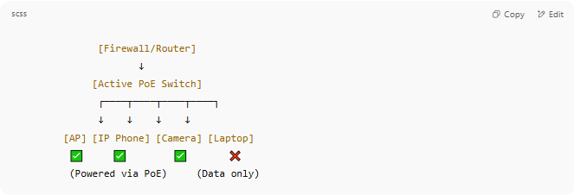

[Firewall/Router]
↓
[Active PoE Switch]
┌────┬────┬────┬────┐
↓ ↓ ↓ ↓
[AP] [IP Phone] [Camera] [Laptop]
✅ ✅ ✅ ❌
(Powered via PoE) (Data only)

- Devices that support PoE are powered.
- Non-PoE devices (like laptops) get only data — safely.

🆚 Active PoE vs Passive PoE
# Source: Chatgpt (GPT‑5 Mini) at [12/18/2025]
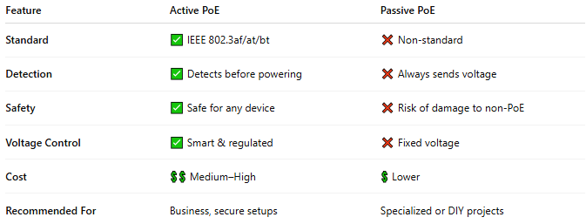

Feature | Active PoE | Passive PoE
Standard | ✅ IEEE 802.3af/at/bt | ❌ Non-standard
Detection | ✅ Detects before powering | ❌ Always sends voltage
Safety | ✅ Safe for any device | ❌ Risk of damage to non-PoE
Voltage Control | ✅ Smart & regulated | ❌ Fixed voltage
Cost | 💲💲 Medium–High | 💲 Lower
Recommended For | Business, secure setups | Specialized or DIY projects

✅ Benefits of Active PoE Switches
# Source: Chatgpt (GPT‑5 Mini) at [12/18/2025]
- ✔ Safe to use with any device
- ✔ Easy to deploy in mixed environments
- ✔ Future-proof and scalable
- ✔ Compatible with standard PoE devices from any vendor

